[Create Course Lecture]

Technical Document

Date: 1/Mar/2019

Version: Version 0.1

# Table of Contents

Table of Contents 1

[Task Name] 2

Description 2

1.1 Mockup screen: 2

1.2 Angular & Spring Models 3

1.3 Angular Component 3

1.4 Rest Services 3

1.5 Flow Services: 4

1.6 Repository Functions 4

# [Create Course Lecture]

Refer to: [Taiga URL]

## Description

Form which collect lecture data and insert it at data base.

## Mockup screen:

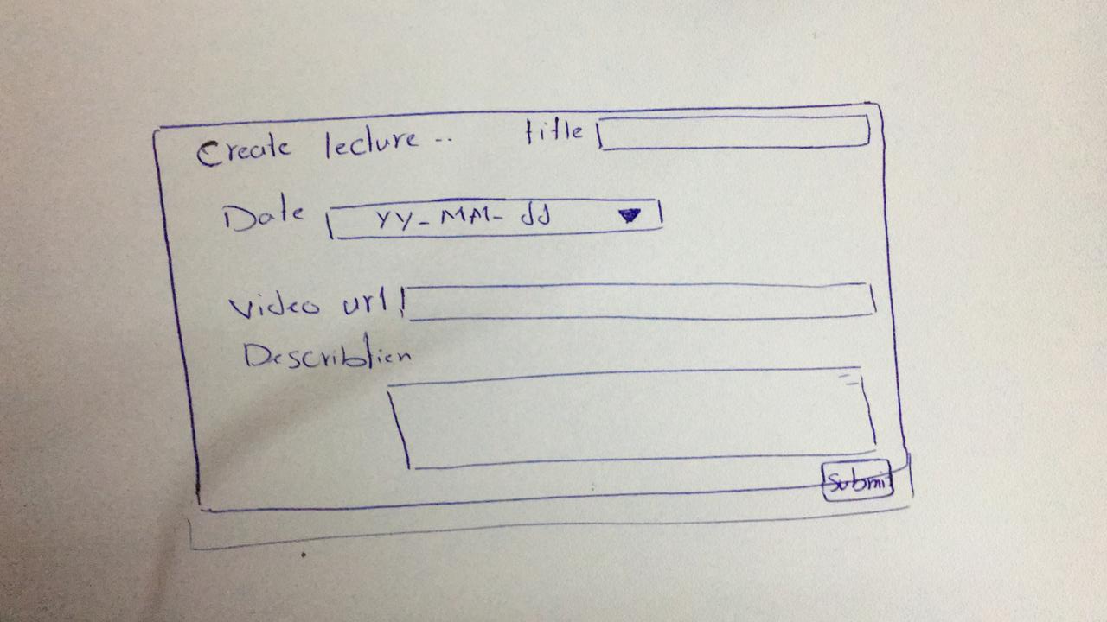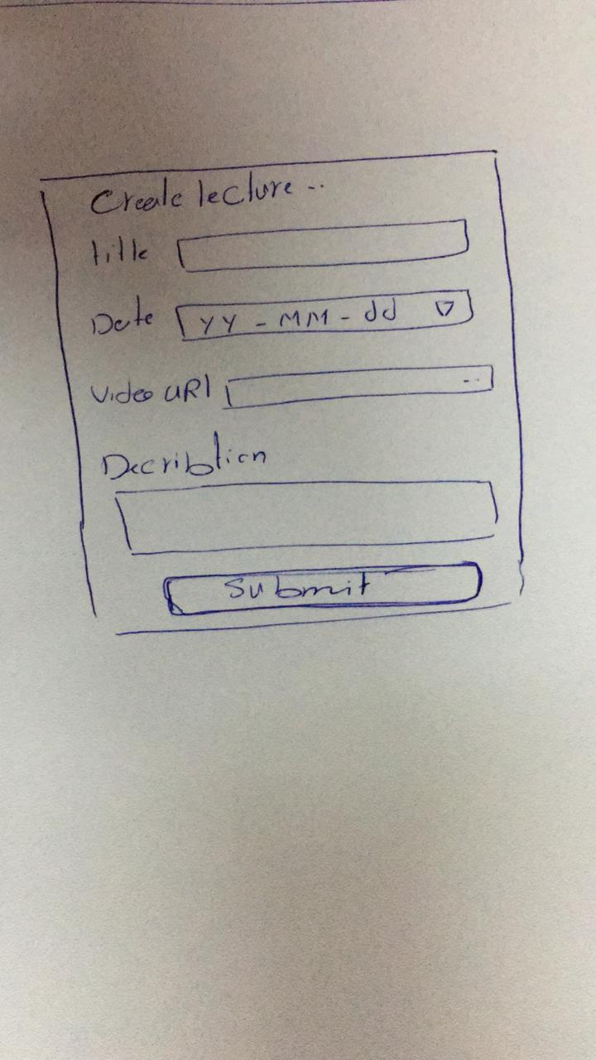

## Angular & Spring Models

|  |  |  |  |
| --- | --- | --- | --- |
| **New** | **Class Name** | LectureDTO | |
| **Angular Path** | | app/modules/course/shared/data/lecture-dto.data.ts | |
| **Spring Path** | | model/course/LectureDTO | |
| **Fields** | | | |
| **Attribute** | | **Angular Data Type** | **Spring Data Type** |
| title | | string | string |
| date | | date | date |
| videoURL | | string | String |
| description | | string | string |

## Angular Component

|  |  |  |
| --- | --- | --- |
| **New** | **Class Name** | CreateLectureComponent |
| **Path** | | modules\course\components\lecture\create-lecture |

|  |  |  |
| --- | --- | --- |
| **New** | **Class Name** | LectureService |
| **Path** | | modules\course\shared\lecture.service.ts |
| **Function** | | submitNewLecture(data: LectureDTO) |

## Rest Services

|  |  |  |  |  |  |  |  |
| --- | --- | --- | --- | --- | --- | --- | --- |
| **New** | **Name** | | api/lecture/new | | | **Method** | POST |
| **Controller** | | | LectureRes | | | **Function** | insertNewLecture  (data: LectureDTO) |
| **REST Parameter** | | | | | | | |
| **Attribute** | | **Parameter Type** | | **Data Type** | **Description** | | |
| data | |  | | LectureDTO |  | | |

## Flow Services:

## Repository Functions

|  |  |  |  |  |
| --- | --- | --- | --- | --- |
| **New** | **Class Name** | LectureRep | **Type** | INSERT SQL |
| **Function** | | insertNewLecture (string sql , data) | | |
| **Query** | | | | |
| INSERT INTO lecture(title , date , video_url , description)Vlaues(?,?,?,?); | | | | |